–

Step-by-step walkthrough for SonarQube Integration with Jenkins

**Jenkins Advance**

PREPARED BY:

PREPARED FOR:

**Version:** 1.0  
**Department:** Architect Department  
**Delivery:** End of Month

Table of Contents

**1.** Lab Summary 3

2. Stage 1: SonarQube Project Configuration 3

A. Create a Local Project 3

B. Generate Token 5

3. Stage 2: Jenkins Plugin & Global Configuration 7

A. Install SonarQube Scanner Plugin 7

B. Add SonarQube Token to Jenkins 8

C. Configure SonarQube Server 11

D. Configure SonarQube Scanner Tool 13

4. Stage 3: Jenkins Freestyle Project Configuration 15

A. Create a New Freestyle Project 15

B. Configure Git Repository 15

C. Prepare SonarQube Environment 16

D. Build Step 17

E. Save & Build 18

5. Stage 4: Jenkins Pipeline Project 20

# Lab Summary

**This document provides a comprehensive guide to To configure SonarQube with Jenkins and enable both Freestyle and Pipeline jobs to perform Code Quality Analysis using SonarQube**



# Stage 1: SonarQube Project Configuration

## Create a Local Project

* Open SonarQube in your browser (http://localhost:9000).
* Click **Create Project** → **Manually**.

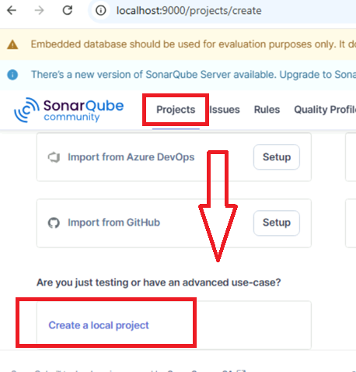

* Enter **Project Key**: **sonar-demo** → Click **Next**

* Use global setting and Create Project

## Generate Token

* Select **Locally** as analysis method.

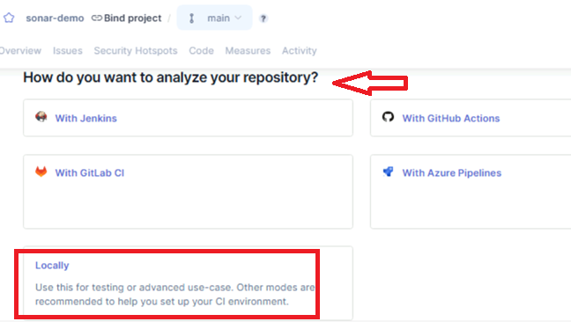

* Enter token name: **gene-token** → Click **Generate**.

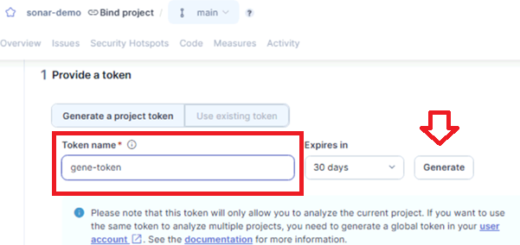

* Copy the token and save it in a secure location (e.g., **Notepad**).

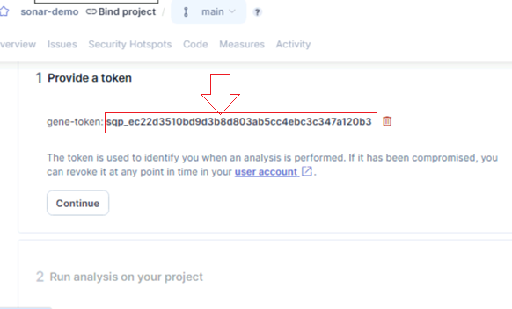

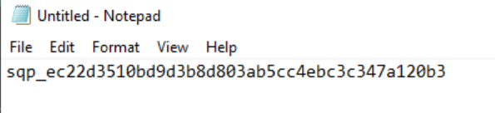

# Stage 2: Jenkins Plugin & Global Configuration

**Steps**

## Install SonarQube Scanner Plugin

* + Navigate to **Manage Jenkins → Plugins**.
  + Search for **SonarQube Scanner for Jenkins** → Install.

* + Select **Restart Jenkins after installation**.

* Post Installation, Jenkins will restart

## Add SonarQube Token to Jenkins

* Go to **Manage Jenkins → Credentials**.

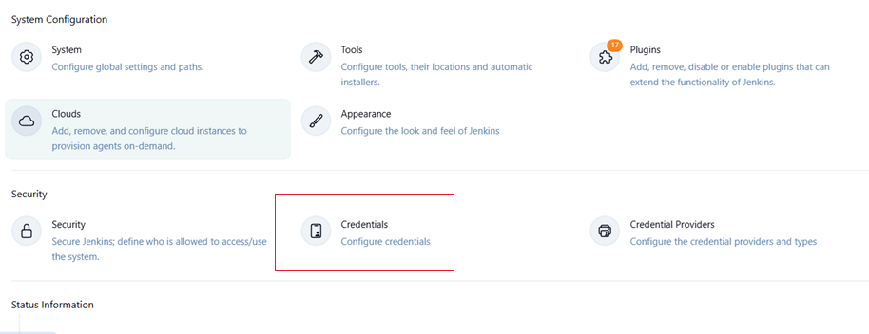

* Click **Add Credential**.

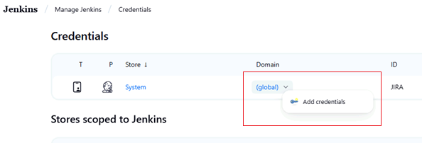

* **Kind:** Secret Text

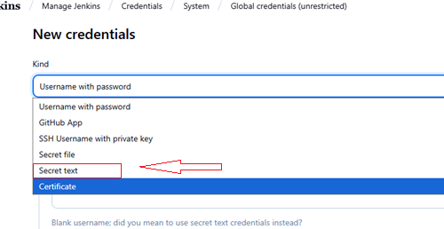

* **Secret:** Paste the SonarQube token  
  **ID:** gene-token  
  **Description:** gene-token

* Create the Secret

## Configure SonarQube Server

* Navigate to **Manage Jenkins → System**.
* Scroll to **SonarQube Servers** → Click **Add SonarQube**.

Now Come to Manage Jenkins and Click System 🡪

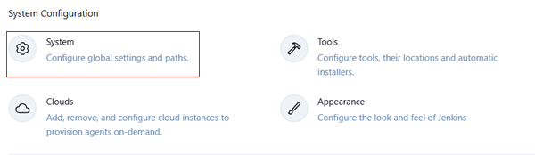

Scroll Down till you SonarQube server

Check the Environment Variable and Add Sonar-Qube

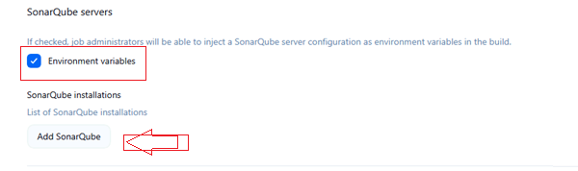

* Fill the details:
  + **Name:** Sonar-server
  + **Server URL:** http://localhost:9000
  + **Server Authentication Token:** gene-token
* Click **Save**.

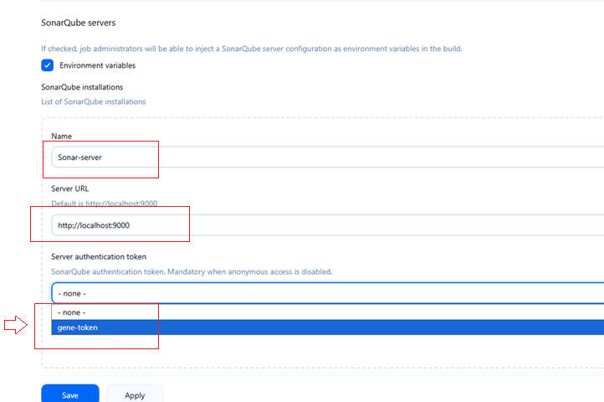

## Configure SonarQube Scanner Tool

* + Go to **Manage Jenkins → Tools**.

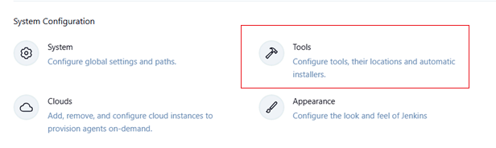

* Scroll down till you see SonarQube Scanner Installation and click Add SonarQube Scanner

* Give only the name “**Qube”** and Click Save

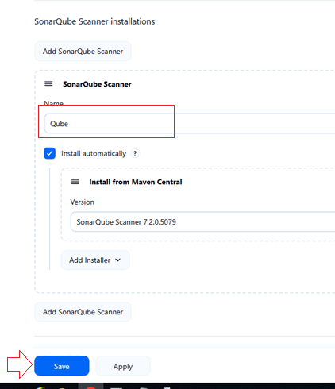

# Stage 3: Jenkins Freestyle Project Configuration

**Steps**

## Create a New Freestyle Project

* + Go to **Jenkins Dashboard → New Item**.
  + Enter a project name → Choose **Freestyle Project** → Click **OK**.

## Configure Git Repository

* In **Source Code Management**, select **Git**.
* **Repository URL:** https://github.com/bipeensinha/webapp.git
* **Branch to Build:** main

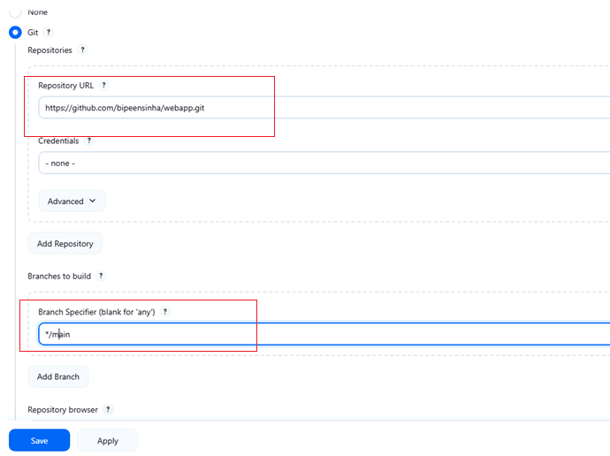

## Prepare SonarQube Environment

* Scroll to **Build Environment**.
* Check **Prepare SonarQube Scanner Environment**.
* Select **None** (if multiple servers not configured).

## Build Step

* Click **Add Build Step → Invoke top-level Maven targets**.
* In **Goals:**

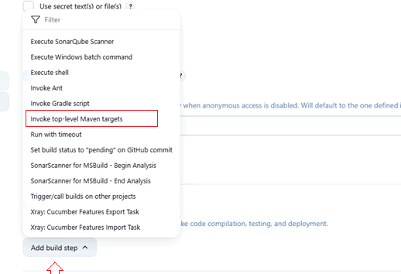

* Now the Goals type

clean package sonar:sonar -Dsonar.projectKey=sonar-demo Dsonar.login=$SONAR_AUTH_TOKEN

## Save & Build

* Click **Save** → **Build Now**.
* Once build completes successfully, click **SonarQube link** in console output to view report.

* Click the SonarQube URL to see the Repo

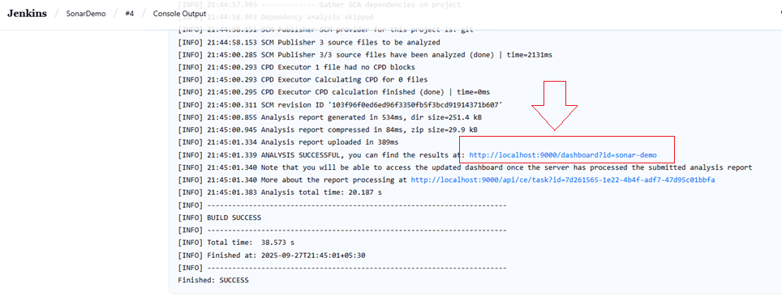

1. Open **Issues** tab in SonarQube to analyze code quality.

# Stage 4: Jenkins Pipeline Project

**Sample Declarative Pipeline**

pipeline {

  agent any

  stages {

    stage('Checkout') {

      steps {

        git branch: 'main', url: 'https://github.com/bipeensinha/webapp.git'

      }

    }

    stage('Build') {

      steps {

        bat 'mvn -B -DskipTests clean package'

      }

    }

    stage('SonarQube analysis') {

      steps {

        withSonarQubeEnv('Sonar-server') {  // Must match the name in Jenkins SonarQube config

          bat """

            mvn sonar:sonar ^

              -Dsonar.projectKey=sonar-demo ^

              -Dsonar.projectName="Sonar Demo" ^

              -Dsonar.host.url=%SONAR_HOST_URL% ^

              -Dsonar.login=%SONAR_AUTH_TOKEN%

          """

        }

      }

    }

  }

}



